Problem Statement:  
During our classroom discussions, we have considered an example of lime juice and its ingredients. Here we consider the following signal:

x(t) = t; 0<t<1 (Yes, you may take the liberty at t=0 and t=1!)

1) We would like to know what does x(t) contain and how much?

2) What would you observe if this x(t) repeats itself with the period T=1? Do components change? If yes, which one and how much? If not, why not!

Substantiate your results in both the cases analytically.

**Solution:**

1. Here, we are given that x(t) = t; 0 < t < 1; Hence, we can say that the signal is CT Aperiodic in nature. Hence, its spectrum has to be continuous in nature. Also, since, the spectrum will be periodic in nature, the component of this signal has to be e^(2*pi*f*t).  
   Here, the component’s amount we are asked to find is in short the spectrum of the signal.

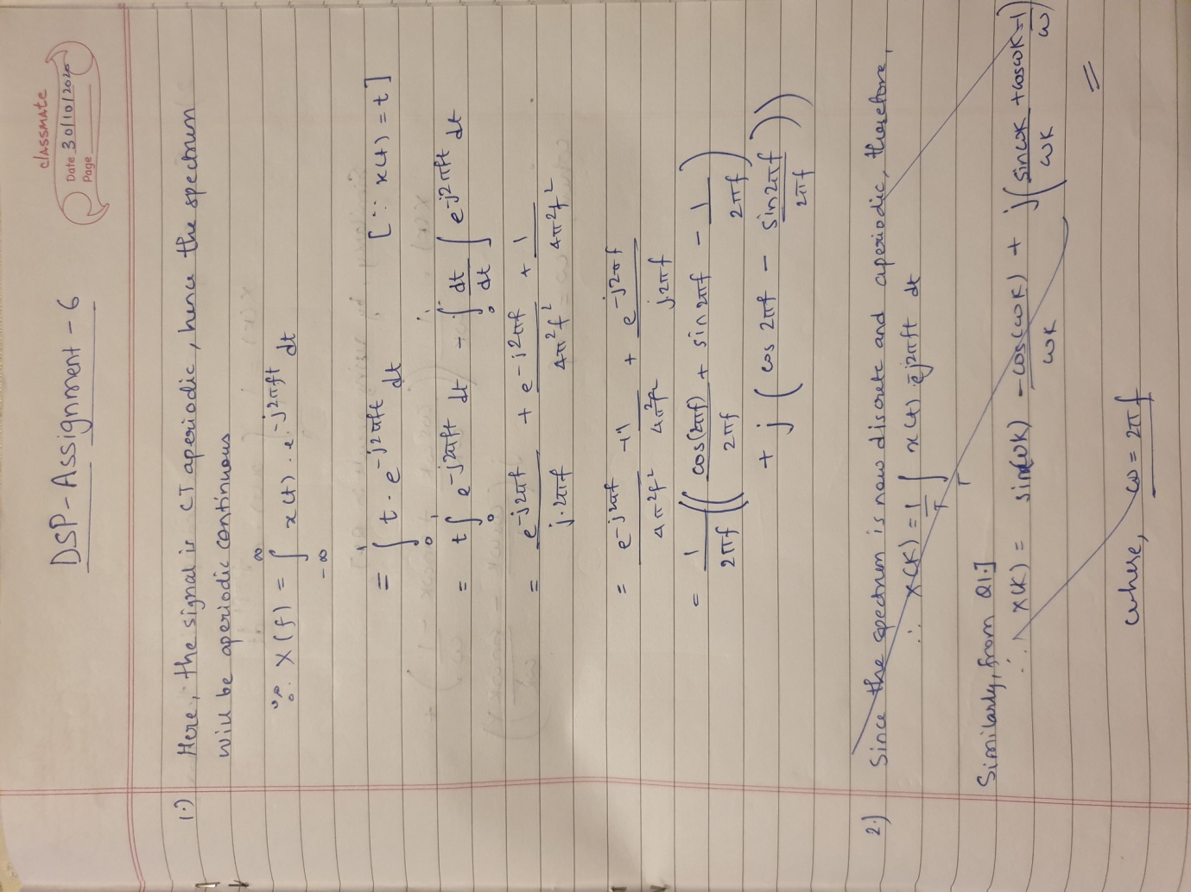

1. If this x(t) repeats itself with the period T=1, x(t) is then a continuous and a periodic signal. Hence, the spectrum will now be discrete and aperiodic in nature. Now, there will be an introduction of ‘k’ in the power of ‘e’ ,i.e, the spectrum becomes digital now. It becomes   
   e^(2*pi*f\***k**\*t).

